Genki I & II

**Other:**

**ee – sound for past tense verbs**

# Random phrases:

なので – since

みたいです – it seems that

# Lesson 5:

～ましょう/ ～ましょうか - Lets

～まで – to (a place), as far as (a place), till (a time)

# Lesson 6:

5: Describe multiple activities (‘and’)

# Lesson 7:

**1. ~ている (action in progress)**

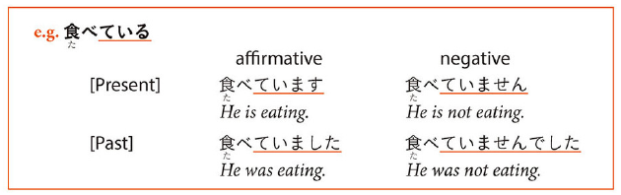

# Lesson 10:

～つもりだ – intend to do, plan to do, intention

3 -adjective/noun + の- avoid repetition, refers to person mentioned previously

To become

Comparison

## 6 - だこかに/どこにも

# Lesson 11:

3: ～ことがある(experience of, something happened, earlier time, I have ‘never’ done that)

たいです – hope or aspiration

# Lesson 12:

～んです – to explain

**Must**

## 3 ～ほうがいいです(Better for you…)

-ないほうがいいですよ

~ので:

なので – since

な at the end of な adjective before ので so なので

# Lesson 13:

1: Do something for me, show something to me くれました

**～し(end of sentence)**

* Mention two or more reasons
* Using one **し** clause implies it is not the only reason
* Sometimes they follow the situation that is being explained
* **し** follows the short forms (except in very polite speech)
* **い** adjective: **面白いし**
* **な** adjective: **好きだし**
* Noun +**です**: **学生だし**

**～そうです** (It looks like)

い-adj: remove い -> replace with そう

* Add **そうです** to adjectives to say something “seemingly” has those properties
* **そうです** is used when you lack conclusive evidence.
  + Before eating: **おいしそう**​→​After eating: **おいしい**
* Using a verb stem with **そうです** describes:
  + Your impression or guess
    - **このセーターはいえで洗えそうです**
  + Impression you express may be an event about to happen
    - **雨が降りそうです** ​←​It looks like it will rain
* Negative ending **ない** changed to **なさ** before **そう**
  + You can also put the negative on **そうです** instead of an adjective
    - **この本は難しそうじゃないです**
* Using adjective + **そう**qualifies a noun. **そう** is considered a **な**-adjective so you have to say (adjective)**そうな**(noun).
  + Example: **暖かそうなセーターをきています** ​←​She is wearing a warm-looking sweater

**～てみる**

Use **て**-form of a verb and **みる** (helping verb) to express the idea of “doing something tentatively” or “trying something out”.

The helping verb **みる** comes from the verb **見る** and conjugates as a regular **る**-verb. It is ​*always* written in hiragana

​**なら**

* Noun A **なら** predicate X = predicate X applies only to A
* You can keep **に**, **で**, and **から** but **は**, **が**, and **を**, never go with **なら**
* Main ideas of a **なら** sentence are
  + Contrast
    - **チリなら行ったことがありますが、ブラジルは行ったことがいません**
  + Limitation
    - **ひらがなならわかります**​→​if it is written in hiragana, I understand
* **なら** introduces a sentence that says something “positive” about the item that is contrasted.

# Lesson 14:

Chapter 14 し and negative

I want – ほし

## 3 – あげる・くれる・もらう

もらう- to receive

くれる- to give

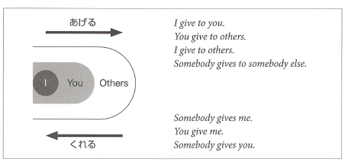

**ほしい**

* Means (I) want (something).
* Considered an **い**-adjective and is usually preceded by the particle **が**. In negative sentences **は** is also used
* It is similar to **たい**in that its use is primarily limited to first person.
* To express it applied to second or third person:
  + Quote
    - Ex. **ロバートさんはパソコンがほしいと言っています**
  + Guess
    - **きょうとさんはクラシックの**CD**がほしくないでしょう**
  + Special verb
    - **ほしがる**. Conjugates as **う**-verb and usually is in the form **ほしがって**

**いる**. The particle after the object is **を**.

o **トムさんは友だちをほしがっています。**

Potential Verbs

* They conjugate as **る**-verbs
* Particles that take particle **を**can take either **を** or **が** when in potential form. **できる** takes **が** almost all the time

|  |  |  |  |
| --- | --- | --- | --- |
| Examples: **私は日本語を話せる** | | | **漢字が読める** |
|  | **私は泳げないんです** | | **山に登れる** |
|  | **仕事ができる** | |  |
|  |  |  |  |
| Verb |  | Present |  |
| **る** | **＋られる** | **見られる** |  |
|  |  |  |  |
| **う** | **＋える** | **読める** |  |
|  |  |  |  |
| **くる** |  | **こられる** |  |
|  |  |  |  |
| **する** |  | **できる** |  |
|  |  |  |  |
|  | **ら**-less |  |  |
|  | potential |  |  |
|  | form |  |  |
| **出る** | **出れる** |  |  |
|  |  |  |  |
| **くる** | **これる** |  |  |
|  |  |  |  |

**～かもしれません**

* May not
* Short form: **かもしれない** or simply **かも**
* Means that something is a possibility; when you’re not really sure but are making a guess
* It goes after the short form of predicates
* It goes directly after the noun or **な**-adjective in present tense affirmative sentences (no **だ**)

# Lesson 15:

Intention/plan/intend to do:

Volitional Form

* Less formal equivalent of **ましょう**
* Use it with **か** to ask for an opinion in offer or suggestion (Shall)

Volitional Form + **と思っています**

* Talk about determinations. “I’ve decided to/ I’m going to”
* **と思います** suggests decision was made on the spot
* **と思っています** suggests you have already decided to do something
* Using present tense= talking about prediction. Using volitional= talking about intention

**～ておく**

* Describes an action done in preparation for something
* Short form + **て**. Often shortened to **とく** in speech
* Ex. **あした試験があるので、今晩勉強しておきます**

# Lesson 16:

## 4 ～時（とき）:While/When something happens

Short form + とき

# Lesson 17:

Phrases:

かな~ I wonder

1: ～そうです (I hear) – I have heard that this thing is….

* Add to end of short form sentence

2: ～って – quote what you have heard

3: ～たら - B is valid only if A is fulfilled

* A たら B

4: ～なくてもいいです – do not need to do

* Negative short form, drop final い



5: ~みたいです – resembles someone / looks like someone / acts like / it seems that

6: ～前（まえ）に／～てから – event before something happens

* Present short form



* After event happens: te-form + から



# Lesson 18:

## 1 - Transitivity Pairs:

Humans act on things / changes that people or things undergo:

Transitive (activities): Subject (agent) + object (thing worked on)

Intransitive (changes): only subject (thing goes through change)

## 2 ～てしまう

Te-fom + しまう

1: “one carries out with determination”

2: “lack of premeditation or control over how things turn out” (sense of regret/not intend to do)

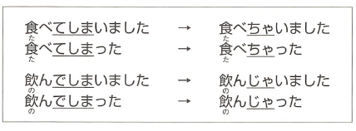

## 3 ～と

Present tense form of a predicate + と: situation described by the predicate holds

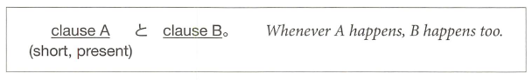

* cause とeffect.

## 4 ～ながら

Connect 2 verbs to say 2 actions performed at the same time

* word stem + ながら (2nd verb {verb after ながら} can be in any form)
* verbstem 1 (u sound -> i sound) + ながらverb 2

## 5 ～ばよかったです

I wish I had done / I should have done something

* describe alternate course of action/regret
* 

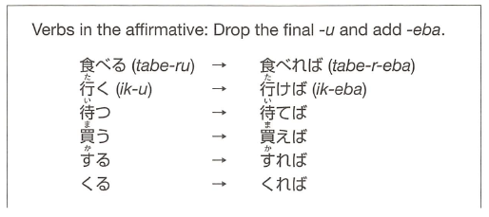

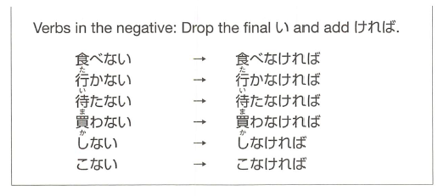

# Lesson 19:

## Honorific Verbs / Graciously

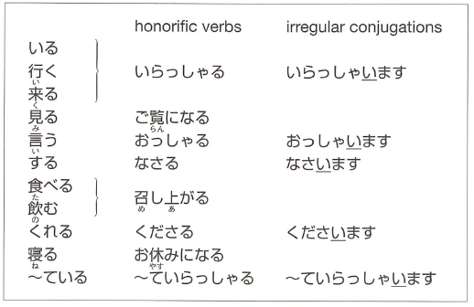

Honorific verbs are not available:

1. ていらっしゃいます instead of ています(if the sentence has the helping verb ている)



* Keep conjugation form example:

社長はたばこを吸います -> 社長はたばこをお吸いになります

おすいになります

* Not すうbut すい (verb stem, conjugated to ‘ee’ sound) as conjugated in the original
* した might become った
  + If it appears that end of a sentence (or with a ‘but’ ~ が’) is した
  + する (なさる) is always なさった

## Giving Respectful Advice

お + verb stem + ください

* するuse ご instead of お

Special honorific verb examples:

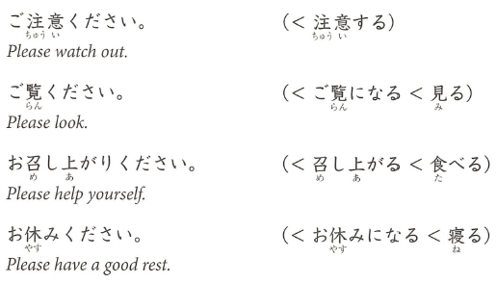

## 3 ～てくれてありがとう

* Express gratitude to someone
* Refer to specific action that you are grateful for

Te form + くれてありがとう



* When honorific is needed (you are not close or social hierarchy)
  + Te-form + くださってありがとうございました

## 4 ～てよかったです

**Xがあります/ います – there is**

* Te-form + よかった: “I’m glad that such and such is/was the case”
  + Negative：te-form なくて
  + Negative te-form reminder: only use the なくて…



“thank you for being such-and-such a person”

* Use でいる instead of です

For giving a reason

* Use the because part (usually second in English) as the first part with dictionary form then the first part afterwards

## 5～はずです

* Sentence ending in short form + はずです: Something is “supposed to be the case”
* What you believe is true/is the case, lack conclusive evidence

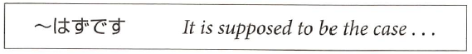

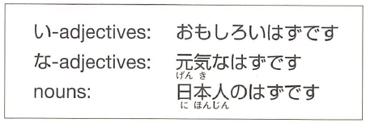

* If present keep する as する and not した
* With potential form keep in ...る form and don’t conjugate

Past tense:

* Something that was supposed to be the case but turned out to be otherwise
* Present tense + はずでした

Negative:

* Negative verb + …たはずです

Something is inconceivable:

* はずがありません and はずがない
* “I cannot imagine”

だったん - was

# Lesson 20

## 1. extra modest expressions

[**https://sethclydesdale.github.io/genki-study-resources/lessons/lesson-20/grammar-1/**](https://sethclydesdale.github.io/genki-study-resources/lessons/lesson-20/grammar-1/)

* Talk modestly of our own actions
* Verbs usually in long form
* Ends sentence with ‘sir’ or ‘ma’am’

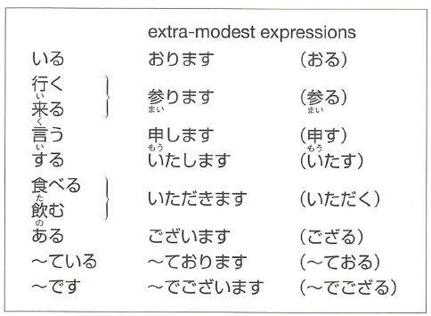

Used to lower your status and elevate the **listeners** status.

From sentences:

V:

今年 [ことし] - this year

N:

卒業 [そつぎょう] – graduation

文化 [ぶんか] – culture

興味 [きょうみ] – interested in something

階 [かい] – story / floor

Phrase:

一年間 [いちねんかん] – period of one year

来年 [らいねん]- next year

examples:

私は来年も日本に **おります**。 (います => おります)

(I will be in japan next year too)

私は今年の六月に大学を卒業いたしました。

I graduated from college this June, sir/ma’am.

お手洗いは二階 **でごいざいます**。 (です => でございます)

(The bathroom is on the second floor)

## 2. humble expressions

To lower your own status and raise the **subject** in your sentence's status

general form:

**お + (verb masu stem) + する。**

for **~する** verbs, usually **ご** instead of お

example:

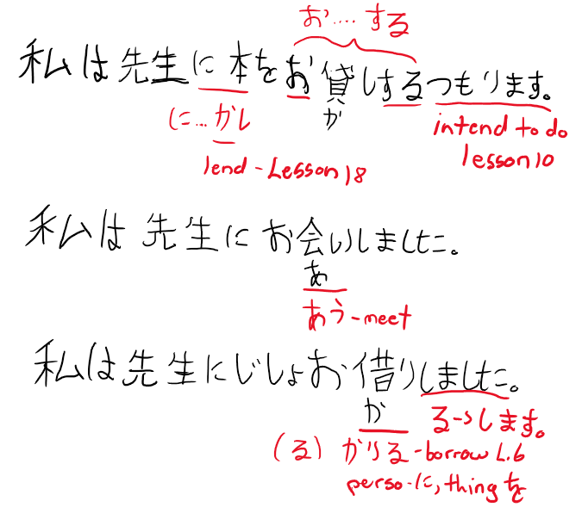

Lend – lesson 18, intend – lesson 10

## する compound verbs, only have ご or お

お/ご + noun + する

**for もらう (to receive – L.14), => いただきます**

**for あげる (to give – L.14), => さしあげる**

**with verb (humbly did an action) て- form+いただきます (did for me)**

**うかがう – humbly visit and ask questions**

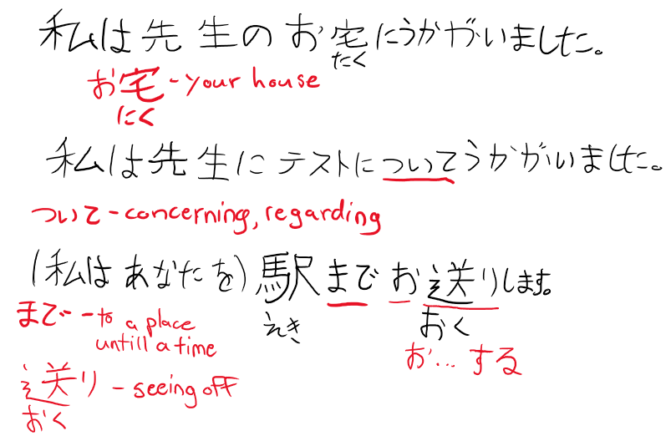

example:

私は先生に花を **さしあげます。**

(I will give my professor flowers)

use the verb **うかがう** to be humble in both visiting and asking questions.

example:

私は先生のお宅に **うかがいました**。

(I visited my professors house)

私は先生にテストついて **うかがいました**。

(i asked my professor about the exam)

note that the extra modest form raises the **listeners** status, whereas humble form raises the **subjects** status (for example the sensei u are referring to in ur sentence)

## 3. without doing X

**verb + ないで = without doing X**

Missed action as ~ない (short negative present) + で

Present form of ~ない for present and past

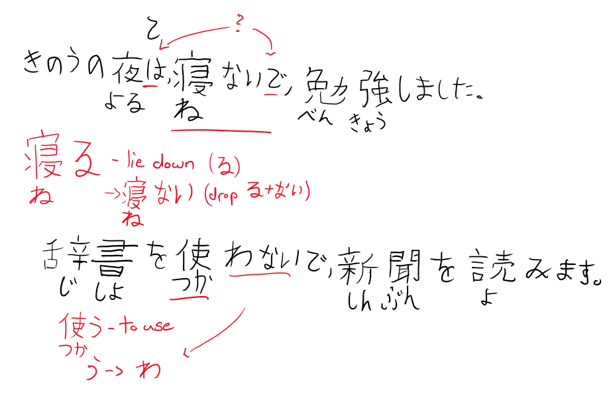

example:

昨日の夜は、**寝ないで**、勉強しました。

(last night, i studied without any sleep)

## 4. questions within larger sentences

you can include questions within larger sentences.

* Quoted questions in short form
* Clause ends with か when it contains だれ or なに
* Clause ends with かどうか when it does not contain a question word

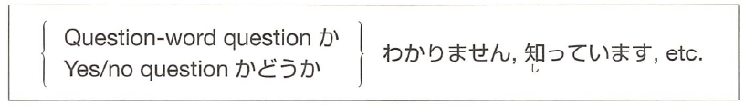

か:

Do you know if…./can/is (currently in the process of..)/where/what…

かどうあ:

Do you know if…. Likes/good at/…

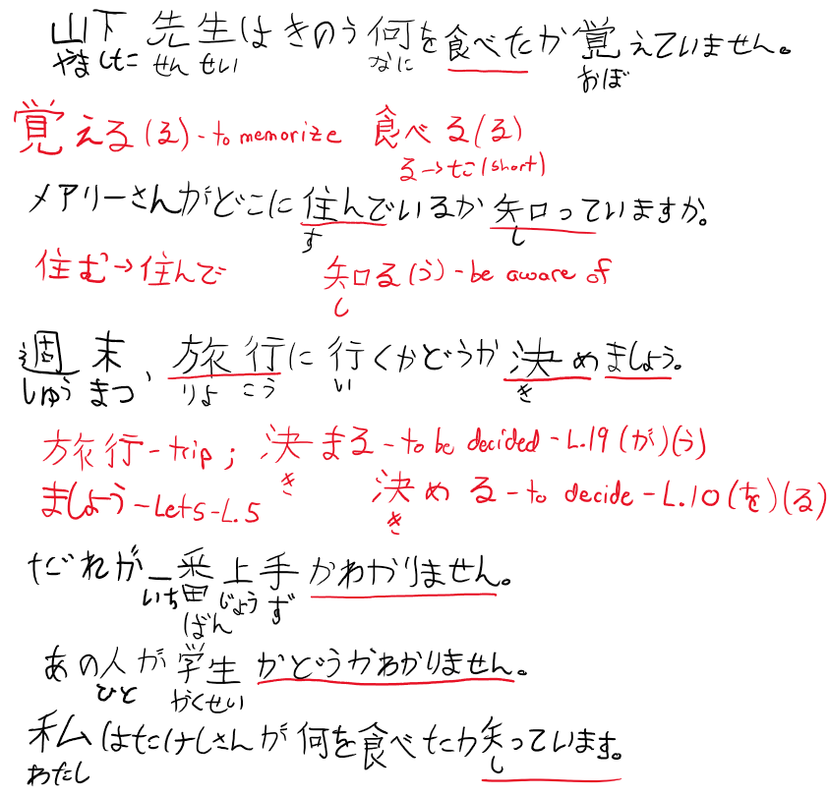

## 5. the name of objects.

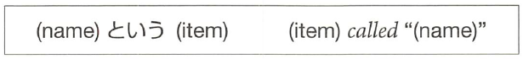

example:

**ポチという犬**。 (the dog called "pochi")

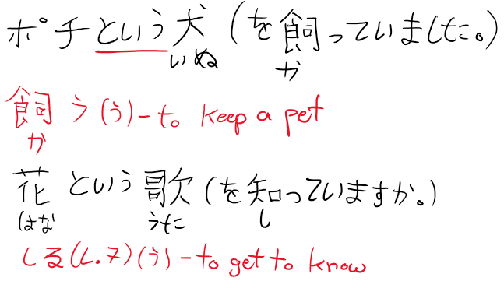

## 6. easy/hard to do

(verb masu stem) + **やすい/にくい** = (verb) is easy/hard to do.

* Easy: verb stem + やすい conjugate like い-adjective
* Hard: verb stem + い-adjective form of にくい
* Place something is easy/hard to do in
* Tool easy/hard to do something with

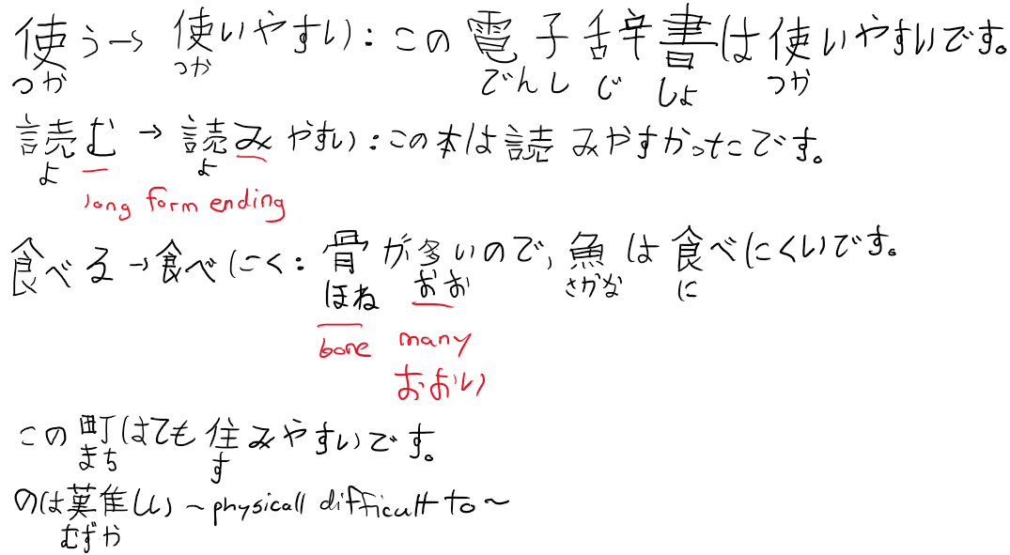

examples:

この電子辞書は**使い やすいです**。

(this electronic dictionary is easy to use)

骨が多いので、魚は**食べ にくいです**。

(because there are many bones, fish are hard to eat)

この町はとても **住みやすいです**。

(this town is very easy to live in)

note that it refers to the psychological state of whether it is easy/hard to do

example:

この雑誌は **買いにくい**。

(this magazine is hard to buy. (because im embarrassed by its contents))

vs

この雑誌を **買うのは難しい**。

(this magazine is hard to buy. (because it is rare and hard to find in circulation)

# Lesson 21

## 1. Passive sentences / inconvenienced by something / bothered by

Passive sentence:

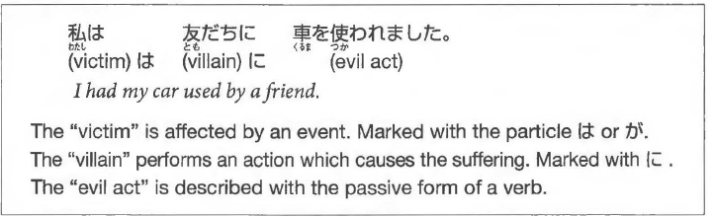

general form:

**X は Y に (verb passive form)**

= X had (verb) done to him by Y.

Passive Forms:

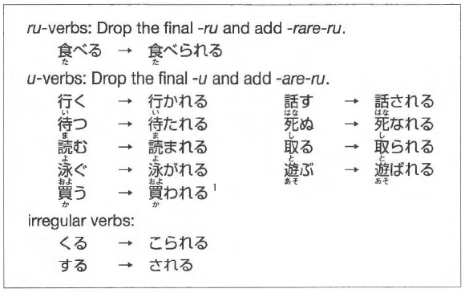

うending becomes ‘w’ (う -> わ) like negative short form

Passive forms ofるand くる are the same as potential form (lesson 13)

Passive formう is different than potential form

Passive forms conjugate as regular る-verbs (including う):

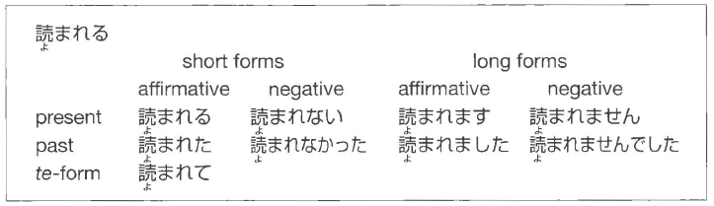

Used for being: angry, embarrassed, sad, and hurt

NOTE: Only used for verbs and not adjectives

* + Situations where something took place due to an action, not that something is described as ‘bad’

Example Sentences:

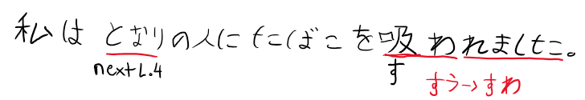

I was annoyed with the person sitting next to me for smoking.

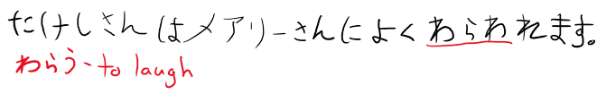

Takeshi is often laughed at by Mary.

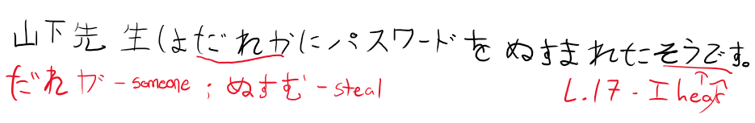

I hear that Professor Yamashita had his password stolen by someone.

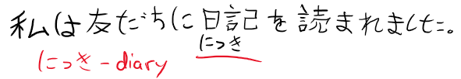

I was annoyed with a friend of mine for reading my diary.

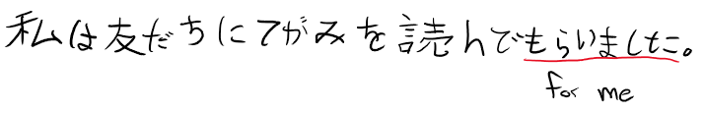

I had a friend of mine read the letter for me.

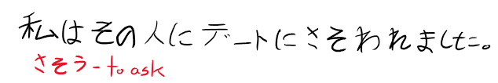

I was asked out by that person for a date.

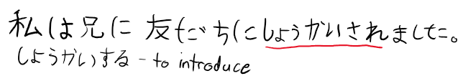I was introduced by my big brother to a friend of his.

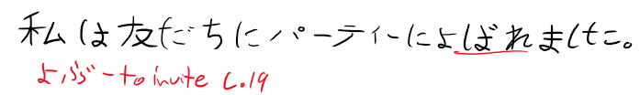I was invited by a friend to a party.

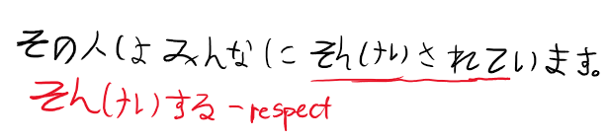

That person is looked up to by most everyone.

Side note:

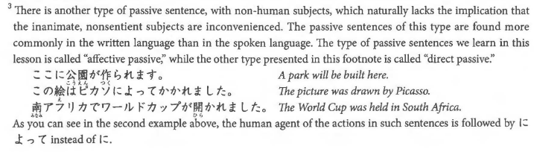

**2. てある**

its kind of like an intransitive form of **ている**。

also implies that something has been brought about **on purpose** by somebody.

example:

窓 が **閉めてあります**。

(the window is closed (by somebody, and is still closed till now))

vs

窓 が **閉まっています**。

(the window is closed (just a statement that it is closed))

**3. 間に**

general form:

A (ている

) **間に** B.

(in the middle of/while A, B)

example:

お風呂に入っている **間に** 電話がありました。

(there was a phone call while i was taking my bath)

A can be a noun:

example:

留守の **間に** 友達が来ました。

(while i was absent, my friends came)

for the above, B lasts for a short duration. if B extends throughout the time A occurs, use **間**

example:

ルームメートがメールを書いている **間**、 私は本を読んで待ちました。

(while my roommate was writing a mail, i waited, reading a book)

**4. to make.**

(adj) + **する** =  to make something (adj)

similar to **なる** and its conjugations too.

i adj:

冷たい => **冷たくする**。

(to make something cold/colder)

na adj:

簡単な => **簡単にする**。

(to make something simple/simpler)

example:

部屋を **きれいにしました**。

(i made the room clean)

**5. i want him to do...**

**(私は) person に (verb) て欲しい。**

= i want person to do (verb)

example:

私 は ルームメート に 宿題を**手伝って欲しい**です。

(i want my roomate to help me with my homework)

u can say i dont want him to do X by negating the 欲しい to **欲しくない** or by making the verb negative + 欲しい。

**Genki chapter 22 grammar notes:**

**1. causative form**

causative form of verb:

ru verb: (ru => saseru)

食べる => 食べ**させる**

u verb: (u => aseru)

行く => 行**かせる**

irregular:

くる => **こさせる**

する => **させる**

general form:

**X は Y に (causative verb)**

= X made/let Y do (verb).

"made/let" depends on context.

example:

お父さんは子供に野菜を **食べさせました**。

(the father made/let the child eat vegetables)

causative form conjugates like ru verb.

if got ~**てあげる、てくれる、てもらう**, usually is let.

(casuative verb) **てください** just means pls let me do (verb)

**2. command**

**(verb masu stem) + なさい** = a command to do (verb).

may sound like u are "talking down" to somebody.

examples:

うちに毎日 **電話しなさい**。

(call home everyday)

文句を言うのを **やめなさい**。

(stop complaining)

**3. ば conditional**

**A ば B** = If A, then B.

conjugation:

all positive verbs: (u => eba)

食べる => 食べ**れば**

行く => 行**けば**

negative verbs: (nai => nakereba)

行かない = 行か**なければ**

ば is usually used when B is a **"good result"/favourable outcome.**

example:

この薬を飲め ば 大丈夫です。

(if u drink this medicine, u will be okay)

however u cannot say "if u dont drink this medicine u will die" using ば cuz the outcome is unfavourable.

**4. despite**

(short form A) **のに** B

= despite the fact that A, B.

both A and B must be **facts**

example:

この会社はお金がある **のに**、給料は安いです。

(Although the company is rich, the workers salaries are low)

when A ends in na adj or noun, add a な at the end of A to become **なのに**.

**5. is like / do something like...**

(noun A) **のような** (noun B) = A is similar to/like B (in appearance/quality)

example:

私は 鎌倉のような町 が好きです。

(i like towns like kamakura)

(noun A) **のように** (verb/adj) =

does (verb) like A / has characteristic (adj) like A.

example:

メアリーさんは **魚のように泳げます。**

(mary can swim like a fish)

私は **孫悟空のように強いです。**

(i am strong like son goku)

**Genki chapter 23 grammar notes:**

**1. causative passive sentences**

general form:

**X は Y に (causative passive verb)**

= X was forced/ordered by Y to do (verb)

example:

ゆみは お母さんに **勉強させられました**。

(yumi was ordered by her mother to study.)

conjugation rules:

ru verbs: (ru => sase rareru)

食べる => **食べさせられる**

u verbs that end in す: (su => sase rareru)

話す =>**話させられる**

all the other u verbs: (u => asare ru)

行く => **行かされる**

irregular:

くる => **こさせられる**

する => **させられる**

**2. even if...**

**A ても、B = even if A, B**

A is in **te-form.**

example:

雨が降っ**ても**、ピクニックにいきます。

(even if it rains, i will go on a picnic)

**3. decide to do**

(verb short form present tense) + **ことにする** = decide to do (verb)

example:

車を買う**ことにしました**。

(we have decided to buy a car)

sometimes volitional form is used eg. **行くことにしましょう**。also means lets do (verb), but has implication that u gave some **deliberation**.

(verb) + **ことにしている**

= do (verb) as a **regular practice.**

example:

絶対にお酒を **飲まないことにしています**。

(i have made this firm decision not to drink alcohol and have strictly followed it)

**4. until**

**A まで、B = until A, continue B.**

example:

晴れる **まで**、喫茶店で待ちます。

(until the sky is clear, i will wait in the coffee shop)

**5. the way of...**

**方** is like **方式** in chinese.

(verb masu stem) + **方** = the way of doing (verb)

example:

考え方 (the way people think)

nouns that come before the verb the を particle changes to **の**.

example:

漢字を読む => 漢字**の**読方 (the way of reading kanji)

for ~する verbs, becomes ~のし方.

example:

日本語を勉強する => 日本語の勉強**のし方**。

(the way of studying japanese)

# Misc.

Days of the week:

|  |  |  |  |  |  |  |
| --- | --- | --- | --- | --- | --- | --- |
| Sunday | Monday | Tuesday | Wednesday | Thursday | Friday | Saturday |
| 日曜日 | 月曜日 | 火曜日 | 水曜日 | 木曜日 | 金曜日 | 土曜日 |
| にちようび | げつようび | かようび | すいようび | もくようび | きんようび | どようび |

Months:

| **Month** | **Japanese** | **Characters** |
| --- | --- | --- |
| January | [ichi-gatsu](https://0.tqn.com/z/g/japanese/library/media/audio/jan.wav) | 一月 |
| February | [ni-gatsu](https://0.tqn.com/z/g/japanese/library/media/audio/feb.wav) | 二月 |
| March | [san-gatsu](https://0.tqn.com/z/g/japanese/library/media/audio/march.wav) | 三月 |
| April | [shi-gatsu](https://0.tqn.com/z/g/japanese/library/media/audio/april.wav) | 四月 |
| May | [go-gatsu](https://0.tqn.com/z/g/japanese/library/media/audio/may.wav) | 五月 |
| June | [roku-gatsu](https://0.tqn.com/z/g/japanese/library/media/audio/june.wav) | 六月 |
| July | [shichi-gatsu](https://0.tqn.com/z/g/japanese/library/media/audio/july.wav) | 七月 |
| August | [hachi-gatsu](https://0.tqn.com/z/g/japanese/library/media/audio/augst.wav) | 八月 |
| September | [ku-gatsu](https://0.tqn.com/z/g/japanese/library/media/audio/sept.wav) | 九月 |
| October | [juu-gatsu](https://0.tqn.com/z/g/japanese/library/media/audio/oct.wav) | 十月 |
| November | [juuichi-gatsu](https://0.tqn.com/z/g/japanese/library/media/audio/nov.wav) | 十一月 |
| December | [juuni-gatsu](https://0.tqn.com/z/g/japanese/library/media/audio/dec.wav) | 十二月 |

End of sentence:

し – List, Chapter 13